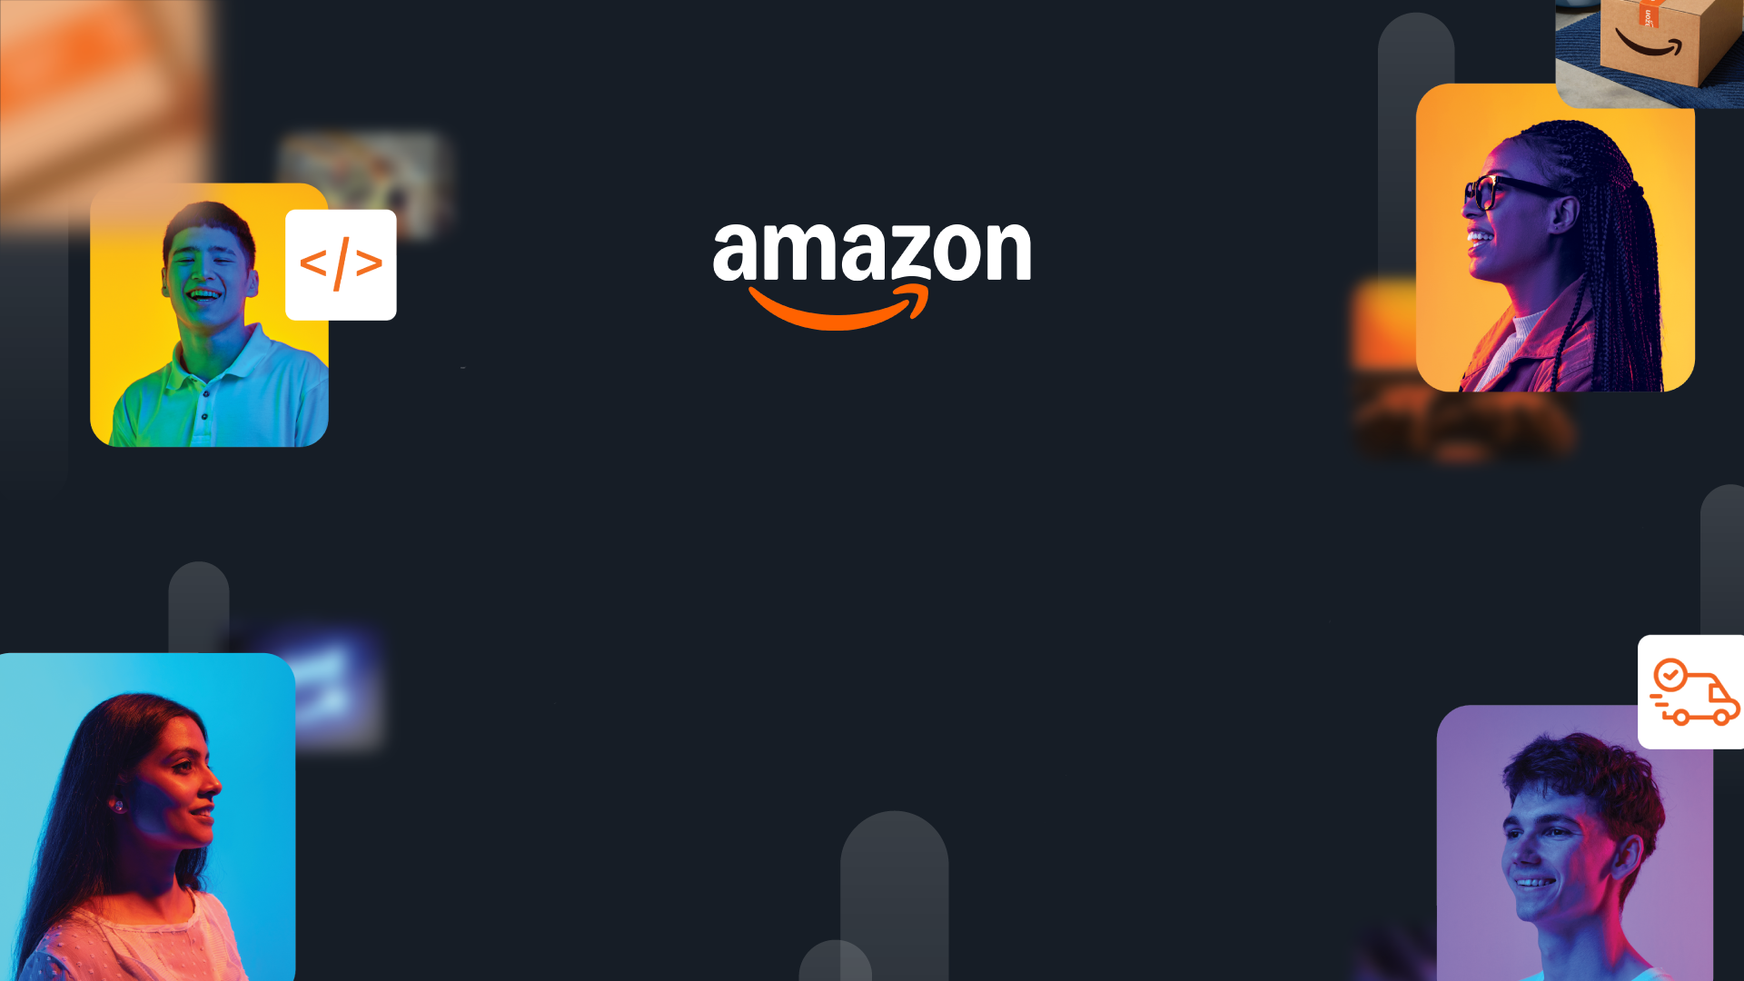

HackOn with Amazon
A Universe of Opportunity
48-Hour Hackathon | Solution Document

Team Name | [Your Team Name]
Hackathon Theme | [Theme Name]
Date | [Submission Date]

Team Members
Name | College / University | Role | Email
[Member 1] | [College] | [e.g., Backend Dev] | [Email]
[Member 2] | [College] | [e.g., Frontend Dev] | [Email]
[Member 3] | [College] | [e.g., ML Engineer] | [Email]
[Member 4] | [College] | [e.g., Designer/DevOps] | [Email]

1. Problem Statement & Relevance
→ Jury focus: Innovativeness (novelty, theme alignment) + Degree of Disruption (global relevance)

The Problem
[What specific problem are you solving? State it in 2-3 sentences. Quantify with data if possible.]

Why It Matters
[Who is affected? How large is the problem? What is the cost of inaction?]
→ Tip: Show global scale. Problems affecting millions score higher than niche issues.

Theme Alignment
[How does this problem connect to the hackathon theme? What is your unique angle?]

What Makes This Novel
[What has not been tried before? What is the insight that makes your approach different from existing solutions?]

2. Customer & Solution
→ Jury focus: Quality of Presentation (clarity) + Quality of Implementation (working prototype)

Target Customer
[Who is your user? Describe the persona in 2-3 lines. What do they need?]

How We Solve It
[Describe your solution in plain language. What does it do? Key features (3-5 max):]
- [Feature 1]
- [Feature 2]
- [Feature 3]

User Workflow
[[Insert a simple diagram or 3-step flow showing how a user interacts with your solution]]
→ A clear visual here directly impacts your Presentation score.

Working Prototype
[[Insert 2-3 screenshots of your working product]]
Demo: [Video/Deployed URL]
→ End-to-end working prototype with evidence = highest Implementation score.

3. Tech Architecture & Scaling
→ Jury focus: Tech Architecture (complexity, algorithms, APIs, code quality) + Scalability (depth, interconnectedness)

Architecture
[[Insert system architecture diagram]]

Tech Stack
Layer | Technology | Why
Frontend | [e.g., React] | [Reason]
Backend | [e.g., FastAPI] | [Reason]
Data/ML | [e.g., DynamoDB, Bedrock] | [Reason]
Infra | [e.g., Lambda, S3] | [Reason]

Key Algorithms & Complexity
[What core algorithms power your solution? Describe complexity and why you chose this approach.]
→ Show thought leadership: novel combinations, creative use of algo/tech, not just standard CRUD.

Scaling Strategy
[How does this handle 100x-1000x growth? Describe horizontal scaling, caching, or distribution approach.]
→ Solutions restricted to local functionality score low. Show global scalability.

4. Future Vision
→ Jury focus: Futuristic Vision (long-term thinking, multi-segment expansion, value impact)

Where This Goes
[What does this become in 1-3 years? What is the big-picture vision?]

Roadmap
Horizon | Milestone | Impact
0-3 mo | [Near-term] | [Users/metrics]
3-6 mo | [Mid-term] | [Users/metrics]
6-12 mo | [Long-term] | [Users/metrics]

Multi-Segment Expansion
[Which other industries, markets, or user segments can this expand to? Describe the path.]
→ Showing clear multi-segment strategy (e.g., healthcare > education > logistics) scores highest.

Value Impact
[Quantify: How many users impacted? What cost savings, efficiency gains, or revenue potential at scale?]

Links: GitHub [URL] | Demo Video [URL] | Live App [URL]

